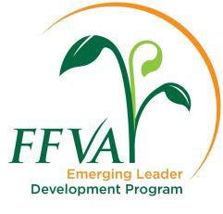

- Acknowledgement of Requirements
By signing this form, I:

  - understand that I must live in Florida and be a current FFVA member for this application to be considered valid
  - understand that attendance at all program activities is mandatory – (PLEASE SEE THE 2023-2024 SCHEDULE)
  - give my permission for contact of the references listed
  - certify that all statements made in the application are true and complete
  - understand that selection of applications is the sole responsibility of the FFVA Leadership Development Committee
  - understand that if I am accepted into the program a $2,000 fee is required
  - understand and acknowledge that throughout the Emerging Leader Development Program photographs and video will be shot during sessions and other program-related activities and may be subsequently published with articles and/or other promotional materials. I hereby give FFVA the unrestricted right and permission to copyright and/or publish such images in which I may be included in whole or part. I also waive the right to inspect and/or approve the finished product or promotional copy that may be used in conjunction with the images

Applicant’s Signature* Date

Supervisor’s Authorization

(applicant) has my permission and support to be involved in the 2023-2024 FFVA Emerging Leader Development Program, including participation in all sessions which will involve approximately 20 days of travel.

Supervisor’s Signature* Date

Supervisor’s Name and Title

*Electronic or script typeface signatures will not be accepted. Please sign and scan this page.

Applications must be received by June 16, 2023 . Send completed application to sonia.tighe@ffva.com. Contact Sonia Tighe at 321-214-5245 with any questions.

